Grasses & Grass like Plants | Characteristics | Conditions | Habitat | Wildlife | Notes
Andropogon Geradii  “Big Bluestem”  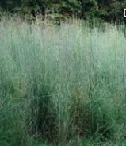 | Height: 2-6.5’  Flower: June-September | Light:  FS PS  Moisture:  D M W | Dry or wet open woods, prairies, swales, shores, dry open areas |  | Clump forming
Panicum Amarun  “Switchgrass”  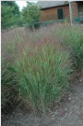 | Height: 3-6’  Flowers: July-October | Light:  FS PS  Moisture:  D M W | Fresh and brackish tidal and non-tidal marshes, open woods, parries, dunes | Songbirds  Waterfowl  Small mammals | Food for sparrow species  Grows in clumps  Controls erosion
Herbaceous Plants | Characteristics | Conditions | Habitat | Wildlife | Notes
Aquilegia Canadensis  “Eastern columbine”  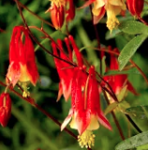 | Height: 0.5-3’  Flowers: April- July red-yellow | Light:  FS PS  Moisture: D M | Rich rocky woods, slopes, cliffs, ledges, pastures, roadside banks | Butterflies  Hummingbirds  Beneficial insects | Commonly cultivated  Spreads b seeds
Arisaema Triphyllum  “Jack-in-the-pulpit”  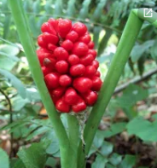 | Height: 1-3”  Flowers: March- June, striped purple or green | Light:  PS S  Moisture: M W | Woods, bogs, swamps | Songbirds | Red berry clusters appear late summer to fall, Unusual flower spreads rapidly from seeds
Asclepias Tuberosa  “Butterfly Weed, butterfly milkweed, butterfly flower”  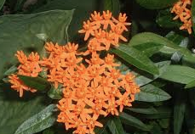 | Height: 1-3’  Flowers: May- July orange | Light:  FS PS  Moisture: D M | Dry fields, roadsides, shale barrens | Butterflies  Beneficial insects | Taproot does not transplant well but seedlings do, attractive seed pod
Baptisia Australs  “wild blue indigo, false blue indigo”  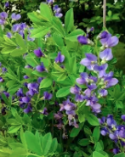 | Height: 3-5’  Flowers: May-June blue, purple | Light:  FS PS  Moisture: D M | Open woods, alluvial thickets, stream banks, floodplains | Butterflies  Beneficial insects | Tolerates poor soil  Flowers very showy  Shrub like form
Campanulastrum Americanum (Campanula Americana)  “American or tall bellflower”  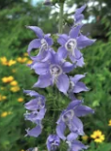 | Height: 1.5-6.5’  Flower: June-August light blue | Light:  PS S  Moisture: M | Rich moist woods, rocky wooded slopes, stream banks
Coreopsis Tripteris  “Tall coreopsis, tall tickseed”  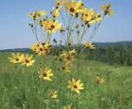 | Height: 3.5-10’  Flowers: May- Sep yellow | Light:  FS PS  Moisture: D M | Thickets, old fields, forest edges, roadsides | Songbirds | Flower has anise scent
Dicentra Eximia  “Wild bleeding heart”  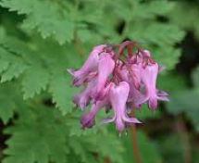 | Height 1.5-2’  Flowers: April-September pink and white | Light:  PS S  Moisture: D M | Rocky woods, cliffs, and rich woods | Songbirds  Beneficial insects | Sometimes cultivated
Geranium Maculatum  “Wild geranium, wood geranium”  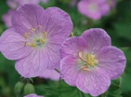 | Height: 1-2’  Flowers: April-July lavender or pink | Light:  FS PS  Moisture: D M | Woods, roadsides, fields | Songbirds  Butterflies  Beneficial insects | Adaptable plant  Long bloom time  Spreader  Herbal uses  Explosive seed capsule
Helenium Autumnale  “yellow or common sneezeweed”  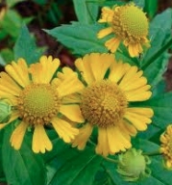 | Height: 1.5-6’  Flowers: July-November yellow | Light:  FS PS S  Moisture: M | Woods, swamps, riverbanks, alluvial thickets, meadows, marshes, ditches | Butterflies | Tolerates wet areas  Showy flowers  Herbal uses
Jeffersonia Diphylla  “Twinleaf”  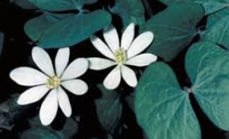 | Height: 0.5-1”  Flowers: April-May white | Light:  FS S  Moisture: M | Rich woods
Lupinus Perennis  “lupine, sundial lupine”  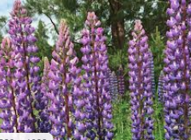 | Height: 1-2’  Flowers: April-July blue, rarely pink or white | Light:  FS PS  Moisture: D M | Open woods, fields, roadsides, stream banks | Butterflies | Prefers acid soil
Phlox Divaricata  “Woodland or wild blue phlox, wild sweet William  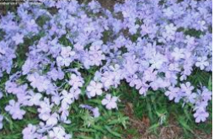 | Height: 1.5’  Flowers: April-June blue, lavender, white | Light:  PS S  Moister:  M | Rich woods | Butterflies | Aromatic  Showy flower  Dormant in summer  Frequently cultivated  Evergreen
Polemonium Reptans  “Jacob’s ladder, Greek valerian”  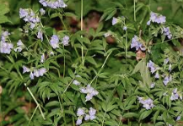 | Height: 0.5-1.5’  Flowers: April-August blue | Light:  PS S  Moistures: M | Woods |  | Flowers dangle along stalk
Rudbeckia Fulgida  “Early eastern or orange coneflower”  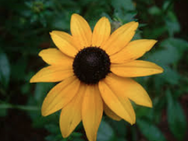 | Height: 1.5-3.5’  Flowers: July-October yellow-orange, elevated black eye | Light:  FS PS  Moisture:  D M | Moist fields, meadows | Butterflies  Songbirds  Beneficial insects | Cultivars have nice foliage
Rudbeckia Hirta  “Black eyed Susan”  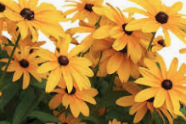 | Height: 1-3.5’  Flower: June-October yellow, black eye | Light:  FS PS  Moisture:  D M | Field, meadows, roadside | Songbirds  Butterflies  Beneficial insects
Solidago Caesia  “Bluestem or wreath goldenrod”  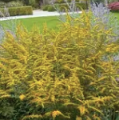 | Height: 1-3.5’  Flowers: August-October yellow | Light:  FS PS S  Moisture:  D M | Rich deciduous woods | Songbirds  Butterflies  Small mammals | Stems bluish or purplish
Solidago Canadensis v. scaba (S. altissima)  “Tall or late Goldenrod” | Height: 3.5-6.5’  Flowers: July-November yellow | Light:  FS PS  Moisture: D M | Woods, fields, riverbanks, roadsides | Songbirds  Butterflies  Small mammals
Solidago Canadensis  “Canada Goldenrod”  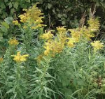 | Height: 1-6.5’  Flowers: July-October yellow | Light:  FS PS  Moisture: D M | Fields, roadsides | Songbirds  Butterflies  Small mammals
Solidago Flexicaulis  “Broad leaf or zig zag goldenrod”  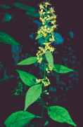 | Height: 1-3.5’  Flowers: June-October yellow | Light:  PS S  Moisture:  D M | Moist woods, rocky wooded slopes | Songbirds  Butterflies  Small mammals
Solidago Juncea  “Early Goldenrod”  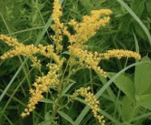 | Height: 1-4’  Flowers: June-October yellow | Light:  FS  Moisture:  D M | Fields, meadows, rocky slopes, roadsides | Songbirds  Butterflies  Small mammals
Solidago Nemoralis  “Gray, dwarf, old-field, or one-sided goldenrod”  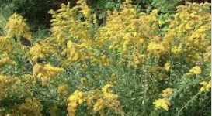 | Height: 0.5-3’  Flowers: June-November yellow | Light:  FS PS  Moisture:  D | Fields, open woods, roadsides | Songbirds  Butterflies  Small mammals
Solidago Odora  “Sweet Goldenrod”  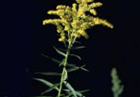 | Height: 1.5-5’  Flowers: July-October yellow | Light:  FS PS  Moisture:  D M | Dry open woods, barrens | Songbirds  Butterflies  Small mammals
Solidago Rugosa  “GWrinkle-leaf or rough-stemmed goldenrod”  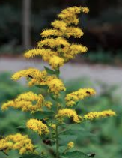 | Height: 1-6.5  Flowers: August-November yellow | Light:  FS PS  Moisture:  M W | Fields, woods, floodplains, waste places | Songbirds  Butterflies  Small mammals  Beneficial insects | Tough plant, aggressive, strongly colonial
Solidago Speciosa  “Showy or slender Goldenrod”  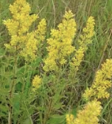 | Height: 2-6-5’  Flowers: July-October yellow | Light:  FS PS  Moisture:  D M | Dry to moist open woods and fields | Songbirds  Butterflies  Small mammals
Symphyotrichum Novae-angliae (Aster novae-angliae)  “New England Aster”  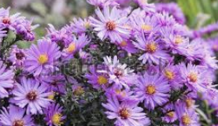 | Height: 1-6  Flowers: August-October violet | Light:  FS PS  Moisture:  M | Open woods, seasonal wetlands, shores, meadows | Butterflies  Small mammals | Showy, frequently cultivate; tolerates drier soils and seasonal flooding
Veronicastrum virginicum (Veronica, virginica)  “Culver’s Root”  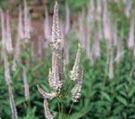 | Height: 3-6.5’  Flowers: June-September white, pink | Light:  FS PS  Moisture:  M W | Rich woods, meadows, thickets, and swamps | Beneficial insects
Herbaceous Emergents | Characteristics | Conditions | Habitat | Wildlife | Notes
Iris Versicolor  “Blue Flag”  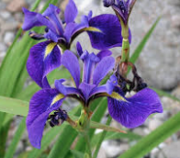 | Height: 3  Flowers: May-June blue | Light:  FS PS  Moisture:  M W | Fresh to moderately brackish tidal marshes, meadows, shores, swamps, forested wetlands | Songbirds  Waterfowl  Small mammals
Iris Versicolor  “Virginia Blue Flag”  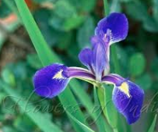 | Height: 1-2’  Flowers: May-July blue | Light:  FS PS  Moisture: W | Fresh to moderately brackish tidal marshes, meadows, swamps, forested wetlands | Songbirds  Waterfowl  Small mammals
Shrubs | Characteristics | Conditions | Habitat | Wildlife | Notes
Aralia Spinosa  “Devil’s Walking Stick”  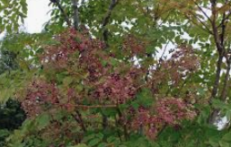 | Height: 20-30’  Flowers: August-September black, berry, fall color yellow | Light:  FS PS  Moisture:  D M | Moist woods, stream banks, roadsides | Songbirds  Beneficial insects  Small mammals
Cornus Amomum  “Silky dogwood, red willow, silky cornel”  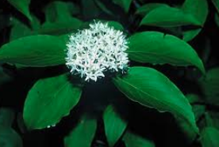 | Height: 6-12’  Flowers: May- June white. August blue berry. Fall color orange, red or purple | Light:  FS PS  Moisture:  M W | Forested wetlands, floodplains, shrub wetlands, stream and pond banks, clearings | Songbirds  Waterfowl  Small mammals
Hamamelis Virginiana  “Witch Hazel”  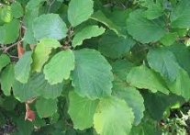 | Height: 15-30’  Flowers: September-December yellow. | Light:  FS PS  Moisture:  D M | Woods or brushy fields, moist or dry | Songbirds  Small mammals | Noted for fall/winter bloom; medicinal use, leaves may persist into winter
Kalmia Latifolia  “Mountain Laurel”  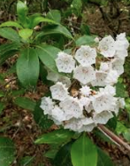 | Height: 12-20’  Flowers: May-July white to pink/purple Evergreen in the fall | Light:  FS PS S  Moisture:  D M W | Woods, ridge tops, fields, swamp, slopes, mountain meadows, | Songbirds  Small mammals | Foliage poisonous to hoofed browsers
Leucothoe RRacemosa  “Fetterbush Sweetbells”  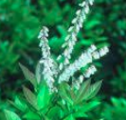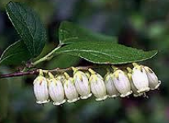 | Height: 13  Flowers: May-June white, pinkish | Light:  FS PS  Moisture:  M W | Woods, swamp, thickets |  | Zig-zag twigs, reddish or greenish; tends to sucker, forming thickets
Lindera Benzoin  “Spicebush”  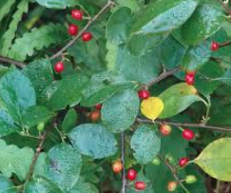 | Height: 6.5-16’  Flowers: March-May yellow  September-October scarlet berry | Light:  FS PS  Moisture:  M W | Woods, wooded slopes, dunes, floodplain forests | Butterflies  Songbirds  Small mammals | All parts edible and aromatic, herbal uses
Ribes rotundifolium  “Appalachian or eastern gooseberry”  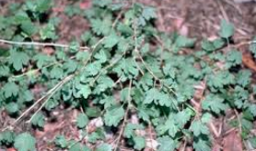 | Height: 3-6’  Flowers: May-July greenish purple July-August purple or greenish berry. Fall color red | Light:  PS  Moisture:  D | Rocky upland woods | Songbirds  Small mammals | Do not use near apple orchards, may spread cedar apple rust
Viburnum Acerifolium  “Maple-leaved arrow wood”  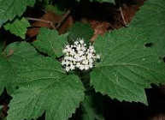 | Height: 3-6’  Flowers: June creamy white pink August-December blue to black berry Fall colors orange, red, purple | Light:  FS PS S  Moisture:  D M | Floodplain forests, dry wooded slopes, woods, rocky slopes, rock outcrops, wooded ravines | Songbirds  Small mammals | Dry edible berries
Viburnum Dentatum “Southern Arrow wood”  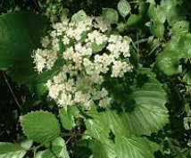 | Height: 10-15’  Flowers: May-June white. September-November blue to black berry. Fall colors reddish-purple | Light:  FS PS S  Moisture:  D M W | Swamp, wet woods, bogs, floodplain forests, stream banks, low wet acid-sand habitat | Songbirds  Small mammals | Stems very straight, nice structure in winter

CODES
- Lights
  - FS (Full Sun) direct sunlight for at least 6 hours
  - PS (Partial Shade) approximately 3-6 hours of direct sunlight
  - S (Shade) receives less than 3 hours of direct sunlight

- Moisture
  - D (Dry) areas where water does not remain after a rain
  - M (Moist) areas where the soil is damp, and may be occasionally saturated
  - W (Wet) areas where the soil is saturated for much of the growing season

